Literature Review on Mobile Edge Computing

Sohaib Ahmed
21L-5635

Muhammad Hassan Khalid
21L-5692

Muhammad Hamza
21L-5636

Introduction:
Mobile Edge Computing (MEC) is a paradigm that brings computational resources closer to end-users, enabling low-latency and high-bandwidth applications. By deploying computing resources at the network edge, MEC reduces latency, enhances user experience, and enables new services such as augmented reality, real-time video processing, and IoT applications.
Literature Review:
- Scalable and Adaptive System Architectures

Wang et al. [4] emphasize the importance of efficient mobility management strategies to address frequent handovers between edge servers. There is a critical need for the development of MEC architectures that can dynamically adapt to changing network conditions and user demands [7]. This includes the creation of scalable system designs that can efficiently manage the increase in workload and support the dynamic nature of mobile applications and services [8].

- Energy-Efficient Computing

Innovations in mechanisms for more efficient energy transfer, along with advanced computation offloading strategies, are crucial to support sustainable MEC operations. Abd-Elnaby et al. [6] provide insights into novel trends and potential research areas, guiding future developments in MEC architectures, applications, and standards. The challenge lies in devising comprehensive system optimization techniques that balance energy consumption with computational requirements, especially in dynamic and resource-constrained environments.

- Unified Security Mechanisms

Security and privacy concerns loom large in the landscape of Mobile Edge Computing (MEC) deployments, necessitating robust measures to counter potential intrusions and data breaches (Abbas et al., [5]). Given the sensitive nature of data processing at the network edge, preserving data confidentiality, integrity, and authentication stands as paramount. Both Abbas et al. and the discussion on unified security mechanisms underscore the urgency of addressing these challenges. A critical research gap lies in formulating cohesive security frameworks that are adept at seamlessly integrating with MEC and its accompanying network infrastructures, including 5G and beyond. Such frameworks must combat a wide range of cyber threats through advanced encryption techniques, access controls, and intrusion detection systems. Harmonizing these efforts is vital to safeguarding user data and network infrastructure alike.

- Resource Management and Optimization

Efficient resource management stands as a cornerstone challenge in Mobile Edge Computing (MEC), as emphasized by Mao et al. [1]. This challenge encompasses the intricate task of balancing computational loads, optimizing resource utilization, and ensuring Quality of Service (QoS) amidst the dynamic nature of wireless environments [2]. Central to addressing this challenge is the strategic allocation of computational and communication resources, a process significantly influenced by informed decisions regarding computational offloading [10]. The decision-making process, as outlined by the formula proposed, considers various factors including job memory requirements, available device memory, job priority, and estimated execution time on the device.

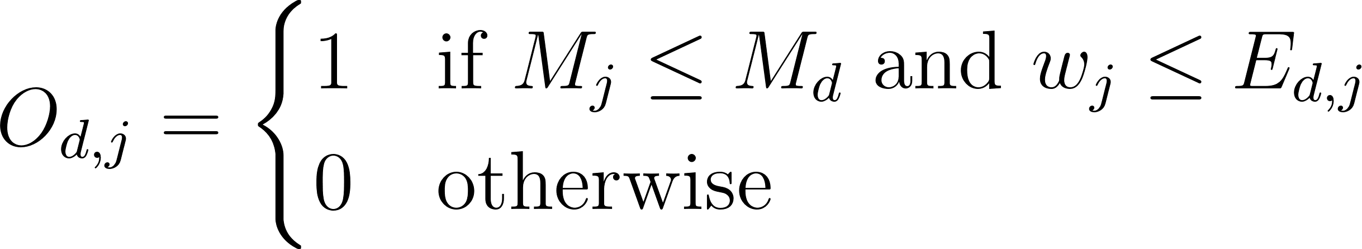

For instance, a job necessitating 500MB of memory may be feasibly offloaded to a device boasting 750MB of available memory, exemplifying scenarios where offloading proves advantageous. However, challenges emerge, such as insufficient device memory or extended execution times for high-priority jobs, potentially diminishing the efficacy of offloading strategies. As such, navigating these complexities requires dynamic adaptation of resource allocation algorithms to maintain performance levels and meet application demands in the face of evolving network conditions.

- Seamless Integration with 5G Technologies

Integrating Mobile Edge Computing (MEC) with traditional cloud infrastructures poses technical challenges, particularly concerning workload distribution and resource allocation [9]. Zhang [3] underscores the complexity in optimizing task offloading decisions and resource allocation policies between MEC servers and centralized cloud data centers, aiming for efficient computational task balancing. To address this challenge, seamless integration frameworks and efficient communication protocols must be developed, ensuring interoperability and resource scalability across heterogeneous environments. Furthermore, as MEC continues to evolve, there is a pressing need for research on its effective amalgamation with 5G and forthcoming technologies. Comprehensive studies are warranted to fully exploit MEC's potential in enhancing network performance and user experience by integrating advanced 5G features such as NOMA, mmWave, and massive MIMO. This holistic approach is vital for realizing the synergistic benefits of MEC and 5G technologies in optimizing network operations and delivering enhanced services to users.

In conclusion, addressing these research gaps and challenges is crucial for realizing the full potential of Mobile Edge Computing and ensuring its successful integration into future network infrastructures.
Methodology
Formulating the Offloading Problem:
The DAEE offloading algorithm is designed to save energy and meet task deadlines by using a virtual queue that mimics real tasks. This method minimizes long-term energy use by considering deadlines and network conditions. By creating a virtual queue through Lyapunov optimization, the algorithm can make smart offloading decisions in real-time without missing deadlines. It sets up a system model with actual and virtual queues to handle tasks efficiently.The system model is represented by the following equation for the distance between the  device and the
MEC server: where  denotes the position of device i, and  represents the MEC server's location.
Lyapunov-Guided Optimization:
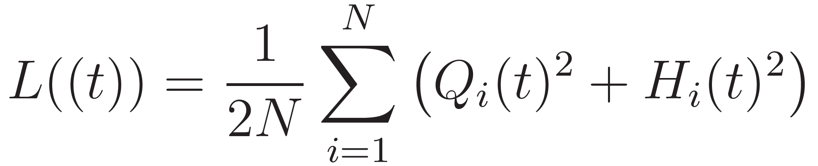
The DAEE algorithm uses Lyapunov optimization to turn the offloading issue into a control problem for keeping the virtual queue stable. The Lyapunov function, is crucial in this process as it shows the overall congestion in the system, with actual and virtual queue backlogs represented by specific variables  and  respectively.

The goal is to minimize a function to balance energy use and speed by making instant offloading choices based on current system status, without knowing future events.
Hierarchical Federated Learning
In Mobile Edge Computing (MEC), security is a big concern due to the distributed setup. To address this, robust security measures are needed to protect data privacy and integrity in a changing 5G environment. The challenge is to create a single security system that can defend against various cyber threats, which is a key area needing more research in MEC.
Hierarchical Federated Learning (HFL) is a model that can help fill this security gap. It works by improving security in a decentralized environment through a dual strategy.
- Local Computation: Defined by the equation This process enables individual edge devices to independently update their security parameters based on local data. This allows for the refinement of security measures at the device level, utilizing firsthand experiences with potential threats while maintaining the confidentiality of the data.
- Cluster Aggregation: This is encapsulated in the equation 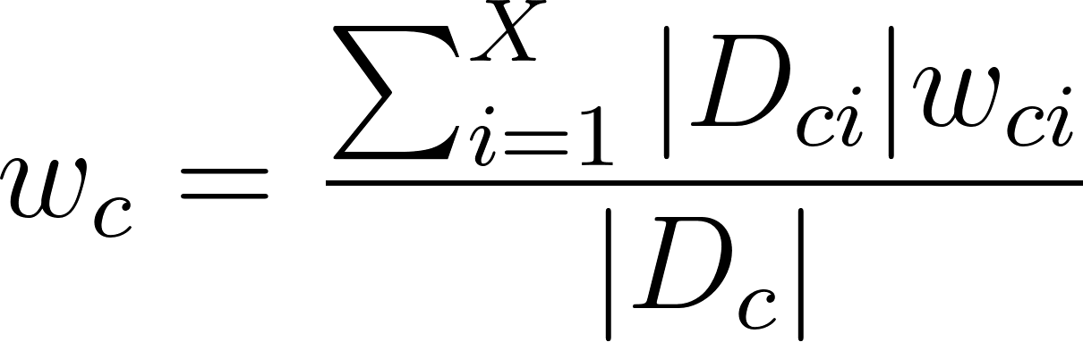, where the model updates at the cluster level are aggregated. It synthesizes the updates from individual devices to form a unified security model. By leveraging the collective learning from various devices, it enhances the overall security framework without compromising data privacy.
In a scenario where three devices choose a security protocol version based on their data, Device A switches from version 1 to 2 after analyzing 5 points of data. Device B always chooses version 3, and Device C prefers version 5 after processing 2 points of data. The decision on the best security protocol version is made by considering each device's choice in relation to the amount of data it has analyzed.
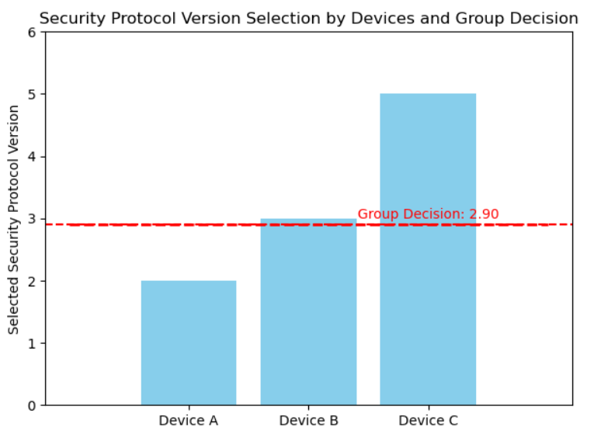

The bar chart shows how individual preferences lead to a group decision on the preferred security protocol version for the network.

The HFL model combines local computation and cluster aggregation to create a strong security system for MEC. It offers a flexible and private way to secure decentralized MEC networks. This model adapts to new data and threats, ensuring a strong and adaptable security framework for future technologies. It not only addresses research gaps but also meets the crucial needs for securing MEC in the 5G era and beyond.
Integration of NFV and SDN
Network Function Virtualization (NFV) and Software-Defined Networking (SDN) are technologies that revolutionize resource management in Mobile Edge Computing (MEC). NFV separates network functions from specialized hardware, enabling them to operate as software on standard servers. This shift allows for agile deployment, scaling, and management of network services, transforming rigid networks into flexible environments. SDN centralizes control over network devices, separating control from data flow. This separation enables real-time traffic management and policy control through software, optimizing resource allocation based on network conditions and application needs. SDN ensures efficient bandwidth use, minimal latency, and adaptive network configurations without manual adjustments.
The integration of NFV and SDN in MEC environments addresses several resource management challenges:
- Dynamic Resource Allocation: NFV and SDN make networks smarter by virtualizing functions and controlling them centrally. This allows resources to be easily moved around to match changing needs, ensuring networks work well and users are happy.
- Scalability and Flexibility: The virtualization of network functions and centralized management of network policies allow MEC infrastructures to scale resources up or down as needed. This scalability and flexibility support the efficient handling of peak loads and the rapid deployment of new services.
- Reduced Latency: With the ability to manage traffic flows and network functions through software, NFV and SDN can help minimize latency by optimizing routing decisions, prioritizing critical data, and placing services closer to the edge of the network.
- Energy Efficiency: By optimizing resource allocation and reducing the reliance on physical hardware, NFV and SDN contribute to energy savings. Virtualized network functions consume less power than traditional hardware-based solutions, and dynamic resource management ensures that resources are not wasted on underutilized functions.
- Operational Cost Reduction: The reduced need for specialized hardware, combined with the efficiencies gained through dynamic resource management, leads to significant cost savings. Operational expenses are lowered as network services can be deployed and managed with greater ease and fewer physical resources.
In conclusion, NFV and SDN upgrade resource management in MEC by offering greater flexibility and efficiency than traditional networks. They virtualize network functions and centralize control, enabling MEC systems to adjust dynamically to user needs, optimizing performance and reliability.
DL and ML for Automated Network Management:
According to the authors Miranda McClellan, Cristina Cervelló-Pastor, and Sebastià Sallent,to handle the complexity of managing many different connections quickly in 5G networks with mobile edge computing, automation is crucial. This means using machine learning in network operations to adapt to changing conditions and locations. By doing this, networks can efficiently provide and manage services and applications, meeting the evolving demands of modern technology.

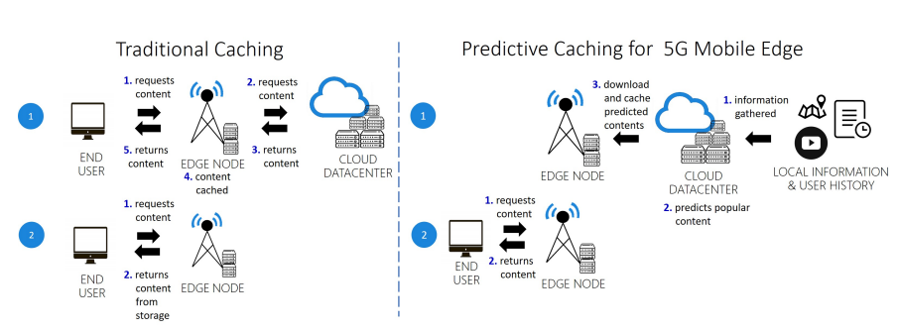
Figure. These two images show the difference between traditional caching and predictive caching using machine learning in mobile edge computing. Step 1 of predictive caching involves downloading popular content that matches a user's predicted preferences from the cloud to the edge node. In the second step, when the user asks for a specific content, there's a better chance that the content is already on the edge node, improving the user experience.
The document discusses various Deep Learning (DL) models and their applications in the context of 5G networks and Mobile Edge Computing (MEC). Here are the key points:

Deep Neural Networks (DNNs):DNNs are essential for function approximation, traffic classification, and network security within 5G networks.

Convolutional Neural Networks (CNNs):CNNs specialize in processing large images, aiding in mobility prediction and object classification for 5G-enabled robotics.

Recurrent Neural Networks (RNNs):RNNs, including LSTM models, excel in handling temporal sequences, benefiting traffic prediction and mobility challenges in communication networks.

Reinforcement Learning (RL):RL, along with Q-learning, excels in training systems to outperform humans in complex games and adapt to dynamic mobile networks for 5G applications.

Non-iterative Detector Design:This model utilizes DL to enhance Bit Error Rate (BER) performance, ensuring reliable communication in 5G networks by addressing inter-channel interference in MIMO-OFDM systems.

Graph Neural Networks:Graph neural networks are utilized for accurate delay estimation in networks with diverse scheduling policies, optimizing edge computing resources in MEC by predicting and minimizing delays effectively.
- Hybrid MIMO Architectures:Millimeter-wave compressive channel estimation architectures enhance data rates and spectrum sharing, enabling faster data processing and transfer in MEC for improved service delivery.
- Q-learning Beamforming: The adaptive technique mitigates inter-cell interference in massive MIMO networks, crucial for 5G signal integrity. In MEC settings, it ensures uninterrupted access to network resources for consistent and reliable computing performance.
- NetXplain: As a real-time explainability tool for graph neural networks, NetXplain aids in understanding AI model decisions. This transparency is beneficial for MEC, where decisions on resource allocation and service provisioning need to be made quickly and accurately.
- AI-based Network Topology Optimization: This approach uses ML to optimize the network topology, which is fundamental for efficient network management. In MEC, an optimized network topology ensures that computing tasks are routed through the most efficient paths, reducing latency and improving service quality.
These models enable automated network management and optimization of resources, latency, and energy consumption, which are crucial for the successful deployment of 5G networks.
Use Cases:
Significant advancements in technology from 2021 to 2024 include the integration of 5G in Mobile Edge Computing (MEC) with the application of Federated Learning for 5G Traffic Forecasting. This method uses federated learning algorithms to predict network traffic patterns accurately, enabling real-time adjustments to network resources. AI has been instrumental in enhancing 5G infrastructures, particularly in the automotive sector for autonomous vehicles. AI integration in devices like Rabbit-R1 enhances digital experiences tailored to individual lifestyles.


The Rabbit R1 device, with AI-driven capabilities and cloud computing foundation, embodies MEC principles by bringing processing power closer to users. Operating on Rabbit OS with the Large Action Model (LAM), it learns tasks from user behavior, enabling real-time applications like advanced navigation systems and Meta glasses, showcasing the transformative impact of AI and 5G on MEC.

REFERENCES

[1] Y. Mao, C. You, J. Zhang, K. Huang, and K. B. Letaief, "A Survey on Mobile Edge Computing: The Communication Perspective," in IEEE Communications Surveys & Tutorials, vol. 19, no. 4, pp. 2322-2358, Fourthquarter 2017, doi: 10.1109/COMST.2017.2745201.
[2] X. Chen, L. Jiao, W. Li, and X. Fu, "Efficient Multi-User Computation Offloading for Mobile-Edge Cloud Computing," in IEEE/ACM Transactions on Networking, vol. 24, no. 5, pp. 2795-2808, October 2016, doi: 10.1109/TNET.2015.2487344.
[3] Y. Zhang, "Mobile Edge Computing for Beyond 5G/6G," in Mobile Edge Computing. Simula SpringerBriefs on Computing, vol 9. Springer, Cham, 2022, https://doi.org/10.1007/978-3-030-83944-4_4.
[4] Xiaojie Wang, Jiameng Li, Zhaolong Ning, Qingyang Song, Lei Guo, Song Guo, and Mohammad S. Obaidat, "Wireless Powered Mobile Edge Computing Networks: A Survey," ACM Comput. Surv. 55, 13s, Article 263 (December 2023), 37 pages, https://doi.org/10.1145/3579992.
[5] N. Abbas, Y. Zhang, A. Taherkordi, and T. Skeie, "Mobile Edge Computing: A Survey," in IEEE Internet of Things Journal, vol. 5, no. 1, pp. 450-465, Feb. 2018, doi: 10.1109/JIOT.2017.2750180.
[6] Mohammed Abd-Elnaby, Germien G. Sedhom, El-Sayed M. El-Rabaie, and Mohamed Elwekeil, "NOMA for 5G and beyond: literature review and novel trends," Wirel. Netw. 29, 4 (May 2023), 1629–1653, https://doi.org/10.1007/s11276-022-03175-7.
[7] A. Kaliwo, C. Nyirenda, "Enhancing Digital Health in 6G Networks: A Cybertwin-driven Fuzzy Approach to Medical Traffic Identification and Classification," by A. Kaliwo, C. Nyirenda, https://www.researchgate.net/publication/378534739.

[8] MABS Abir, MZ Chowdhury, "Digital Twin-based Aerial Mobile Edge Computing System for Next Generation 6G Networks," by MABS Abir, MZ Chowdhury, https://www.researchgate.net/figure/The-architecture-of-the-proposed-DT-based-aerial-MEC_fig1_378194844.
[9] W. Yu, TJ Chua, J. Zhao, "Orchestration of Emulator Assisted Mobile Edge Tuning for AI Foundation Models: A Multi-Agent Deep Reinforcement Learning Approach," by W. Yu, TJ Chua, J. Zhao, https://doi.org/10.48550/arXiv.2310.17492.
[10] S. Roy, S. Kalafatis, "RoboCon: A Modular Robotic Containerization, Orchestration, and Load Balancing Technique for Mixed Hierarchy Task Handling Across Computing Platforms," by S. Roy, S. Kalafatis, https://www.researchgate.net/publication/378617477.
[11] “Deep Learning at the Mobile Edge: Opportunities for 5G Networks” by authors Miranda McClellan, Cristina Cervelló-Pastor, and Sebastià Sallent from the Department of Network Engineering at Universitat Politècnica de Catalunya (UPC).

